PPP-Stand, Builders Guide and Users Guide
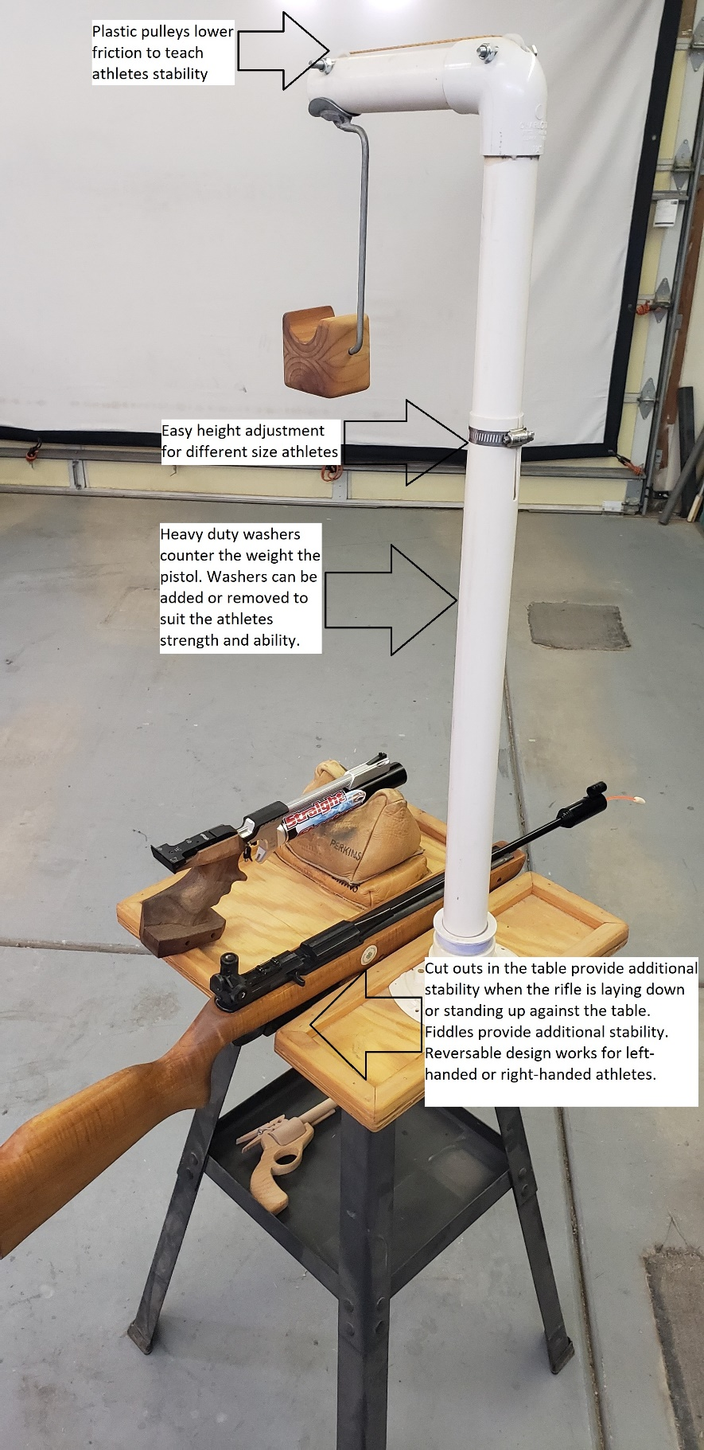
(2) 1” plastic screen door pulleys from Amazon
(2) ¼” x 2 ½” bolts for axles for the pulleys
(1) 1 ¼” PVC 90⁰ elbow
Four feet of 3mm paracord from Amazon
The pistol hanger is a modified 4” paint roller frame.
The pistol rest is made from scrap lumber.
Important: the center of gravity must be below the hanger so it does not flip over when the pistol is removed. That is an athlete distraction that can lead to safety issues.
Three feet of 1 ¼” PVC pipe.
Hose clamp for easy height adjustment.
Stack of 1 ½” washers inside the PVC to counterbalance the weight of the air pistol.
(1) ¼” x 5” eyebolt for the stack of washers.
(1) ¼” nut for the eyebolt.
Two feet of 1 ½” PVC Pipe. Get the right thickness(schedule) for it to slip fit over the 1 ¼” upper PVC pipe.

(1) 1 ½” to 2” PVC bushing to connect the PVC pipe to the Shower Drain.
(1) 2” ABS Shower Drain Base bolts to the platform.
(4) 3/16” x 1” bolts to attach the shower drain to the platform.
Ornamental wood moulding to create fiddles around the edge. This helps prevent equipment from rolling off the stand and makes the stand stiffer for stability.
¾” plywood base 16” x 24” (material efficiency)
Four rubber feet on the bottom of the plywood. Prevents the stand from sliding around on the table for safety.
PPP-Stand can be placed on a portable table or bolted onto a Harbor Freight tool stand.

The curved surface of the washer will stabilize the pistol rest when the athlete removes the pistol from the stand. If the rest twists it will become a distraction for the athlete.

The curved shape of the rest will provide a comfortable and stable platform for the athlete’s arm or pistol while they shoot. This will allow the athlete to concentrate on shooting fundamentals without the distraction of the pistol slipping off the rest during their shot routine.

Other necessary items include: PVC glue, wood glue for the pistol rest, JB Weld for the pistol hanger and wood stain for the plywood base.
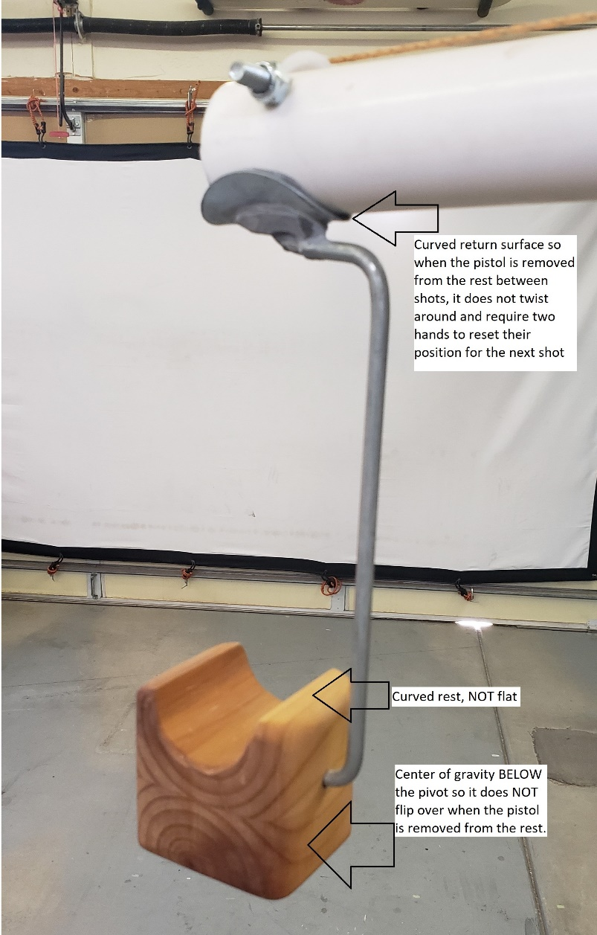

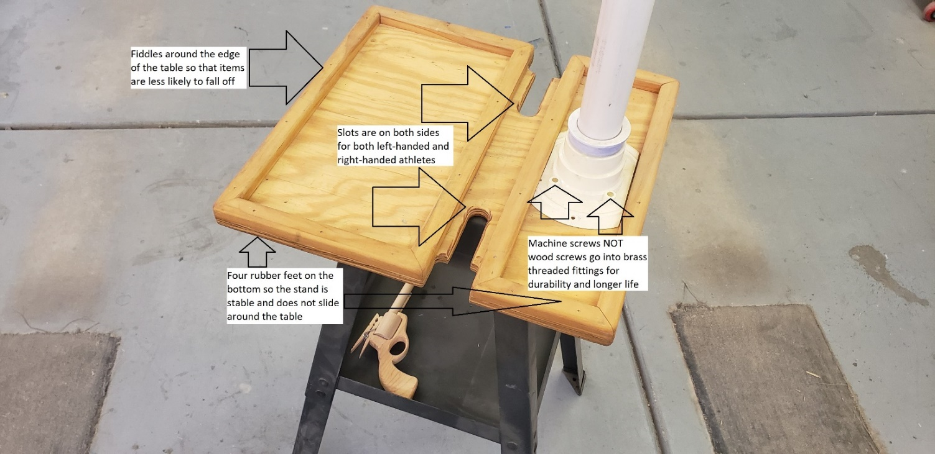
Coach, what do you notice about this beginner athlete?
Beginner athlete development on the PPP-Stand
To all Coaches, shooting is fun. If your athletes are not having fun, you need to reflect on your style and purpose as a Coach. Athletes have plenty of opportunities to do other things. Provide the environment where the athletes want to shoot.
Coaches should test every athlete for eye-dominance. Eye dominance is not strictly binary (left or right). It is a spectrum. A coach that does not understand this is likely to mis-diagnose an athlete’s challenges.
Beginner athletes should start their career shooting from a seated position with the pistol sandbagged.
This allows the athlete to concentrate on learning the two most important pistol shooting fundamentals; sight-alignment and trigger control without concern for stance or hold control. Once an athlete develops the skills to consistently keep all shots inside the seven-ring on a 10m air pistol target, they can move on to shooting in the standing-supported position using the PPP-Stand.
Occasionally returning an athlete to the seated-sandbagged position is a good exercise to test the development of their shooting fundamentals.
All athletes should use an occluder over their non-dominant eye to reduce eye strain. Athletes attempting to close one eye while they shoot cause eye strain in both eyes that hinders their performance.
“CCT Clip-on 30mm Eyeshield Eye blinder ISSF” from E-bay.
Do not use scotch tape on an athlete’s prescription glasses. This may damage the anti-glare anti-reflection coatings that were an additional expense for their parents.
It is acceptable to use Scotch tape on cheap range glasses if occluders are not available.
Athletes should ensure that the hanger on the PPP-Stand should hang vertically, not fore/aft or side-to-side for shot consistency. Adjust where the athlete is standing to get the rest to hang vertically.
The athlete should ‘anchor’ their non-shooting arm in a comfortable position. Put the non-shooting hand in a pocket or hook the thumb in a belt loop; not hanging loosely from the shoulder.
Keep the feet squarely under the shoulders in a natural standing position without a twist in the spine.
As an athlete develops strength, balance and shooting fundamentals, gradually move their foot position from an open-position (body facing the target) to an in-line (feet parallel with the firing line) position. This in-line position uses the latissimus dorsi muscle instead of the pectoralis muscle for greater endurance and stability.
The pistol rest on the PPP-Stand may be used anywhere from the muzzle of the pistol to the athletes shooting elbow. Most athletes will be best suited to use the support near the wrist.
There is no maximum counterweight limit on the PPP-Stand but: we are trying to develop an athlete’s standing position.
To much counterweight is counterproductive to developing an athlete’s strength and skills. I limit the maximum weight to less than the weight of the pistol.
Athletes that are converting to standing-supported position may not have the endurance to shoot a 40-60 shot practice. Coaches can help them adapt to their endurance as they build strength. Athletes can start practice shooting 15-20 shots from the seated-supported position. Then shoot 15-20 shots from the standing-supported position. Finish with 15-20 shots from the seated-supported position. Gradually build their endurance at each practice.
Get the athlete off the stand as soon as they are ready. It is only a training tool to transition from the seated-position to unsupported-standing. The PPP-Stand can help teach; endurance, stance, balance, breathing, timing, lift and follow through.

